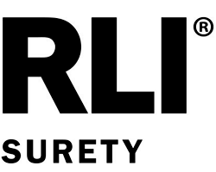
P.O. BOX 3967 PEORIA, IL 61612-3967
P: (800)645-2402 E: surety.east@rlicorp.com
RLISURETY.COM

RIDER

TO BE ATTACHED TO AND FORM PART OF BOND/POLICY NO.

It is hereby mutually agreed and understood by the Principal,

and RLI Insurance Company that the
Amount
(Identify item(s) to be changed)
on this bond/policy has/have been changed to the following:

Nothing contained herein shall vary, alter, waive or extend any of the terms, limits, or conditions of the bond/policy, except as set forth above.

This Rider becomes effective on 28 May 2024 , at twelve and one minute o'clock a.m.,
Standard Time.

Signed this 28 , Day of May , 2024 .



RLI Insurance Company
By 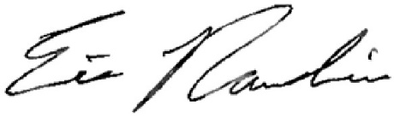

Eric Raudins Sr. Vice President

